NWRI GRADUATE FELLOW PROGRESS REPORT
DATE: July 31st 2025
Project Title: Anion Exchange Membranes with Tunable Hydrophobicity for the Selective Removal of Nitrate from Contaminated Brackish Groundwater
Full Name: Harsh Patel
Advisor: Dr. Jovan Kamcev
Institution: University of Michigan – Ann Arbor

Background and Introduction
The global imperative of achieving food security, particularly in developing nations, has led to extensive utilization of nitrate-based fertilizers, crucial for plant protein and enzyme production.^{1,2} However, their excessive use contributes to nitrate pollution in water bodies, primarily through leaching into groundwater and surface water. Upon consumption, nitrate-contaminated water poses health risks, as nitrate can convert to nitrite, hindering oxygen transport in the blood. While WHO and EPA recommend nitrate concentration limits (<50 mg/L), many regions struggle to meet these standards due to inefficient nitrate removal methods.³ Biological denitrification, while effective, removes accessible nitrogen from the environment. Alternatively, electrodialysis (ED) shows promise for nitrate removal. This membrane-based technology employs ion-exchange membranes (IEMs) and an electric field to segregate ions of differing charges. IEMs are polymeric membranes containing positively or negatively charged functional groups covalently bound to their backbone (i.e., fixed charges).^{4,5} However, most commercial IEMs cannot discriminate between different counter-ions, particularly those that have similar size and charge (e.g., NO₃⁻/Cl⁻) since the main mechanism for separation is electrostatic exclusion. Previous studies have attempted to leverage differences in ion hydration energy to increase NO₃⁻/Cl⁻ and NO₃⁻/SO₄²⁻ selectivity.⁶ Specifically, some studies have shown that membranes with hydrophobic fixed charged groups (FCG) can enhance the transport of lesser hydrated ions, such as nitrate, which is attributed to the partial loss of water molecules in the hydration shell of the ion.⁷ It is hypothesized that ions with lower hydration energy can undergo easier dehydration, resulting in a lower energy barrier for the transport from the solution into the membrane.
Previous studies that have synthesized hydrophobic membranes have shown improved NO₃⁻/Cl⁻ and NO₃⁻/SO₄²⁻ selectivity; however, their complex synthesis is difficult to scale up and involves the use of hazardous solvents (i.e., THF and NMP).^{8,9} Additionally, the effect of FCG hydrophobicity on counter-ion selectivity is not properly assessed in these studies as other membrane properties are not isolated. This motivates the need for controlled and systematic studies to study the role of membrane hydrophobicity on ion selectivity. A central objective of this study is to systematically study the effect of membrane hydrophobicity on nitrate selectivity by synthesizing highly charged ion-exchange membranes using a one-step, environmentally friendly process. This study will also investigate the thermodynamic and mass transport behavior of the membranes in mixed salt solutions. In the process, we hope to develop a toolkit for synthesizing highly charged nitrate-selective IEMs and create transformative advances in nitrate recovery (Figure 1).
Figure 1. Central goals and objectives of this work

Progress to Date
Part 1: Synthesis and characterization of AEMs with varying FCG hydrophobicity
I successfully controlled the FCG hydrophobicity of the AEMs by changing the length of the alkylated quaternary ammonium groups. This involved performing an amine alkylation reaction between an alkyl halide and a tertiary amine. I used inexpensive commercially available monomers with tertiary amine groups as well as primary alkyl halides to perform the reaction. Two amine reagents were used, and I modified the length of the alkyl halide to yield a charged monomer with pendant alkyl chains with varying lengths (Figure 2). The reaction conditions (temperature, stoichiometry, concentration) were optimized to yield the charged monomers with high yield and purity. Characterization of the synthesized monomers included nuclear magnetic resonance (NMR)spectroscopy and Fourier transform infrared spectroscopy to confirm the molecular structure of the resulting product.
Figure 2. Synthesized charged monomers with varying pendant alkyl chain length for this work

For the next objective, I used a synthetic approach developed in our lab, now under a patent application, to synthesize homogeneous membranes with the charged monomers shown in Figure 2. The main advantage of this process is that it allows the synthesis of homogenous IEMs with systematic control of membrane properties like charge density and water content for different IEMs, which is critical for fundamental studies on membrane transport. I used a heat-induced free radical polymerization involving the reaction of a crosslinker, a charged monomer, and an initiator in a mutual solvent (water) to obtain a cross-linked random copolymer network. Choosing monomer and cross-linker pairs with similar functional groups results in favorable mixing interactions. Therefore, a judicious combination of monomers can form homogenous mixtures using little solvent and large amounts of charged monomer and cross-linker. I adopted this synthetic approach used for to create novel nitrate selective membranes using the charged monomers synthesized. Because of the tunability of this synthetic process, I can combine different amounts of the charged monomers (varying alkyl chain length), solvent (water), and crosslinker to yield membranes with similar fixed charge density and water volume fraction to isolate the effect of fixed charged group hydrophobicity (Figure 3). Achieving this was central to understand how changing the environment around the fixed-charged group affects the selectivity of nitrate.
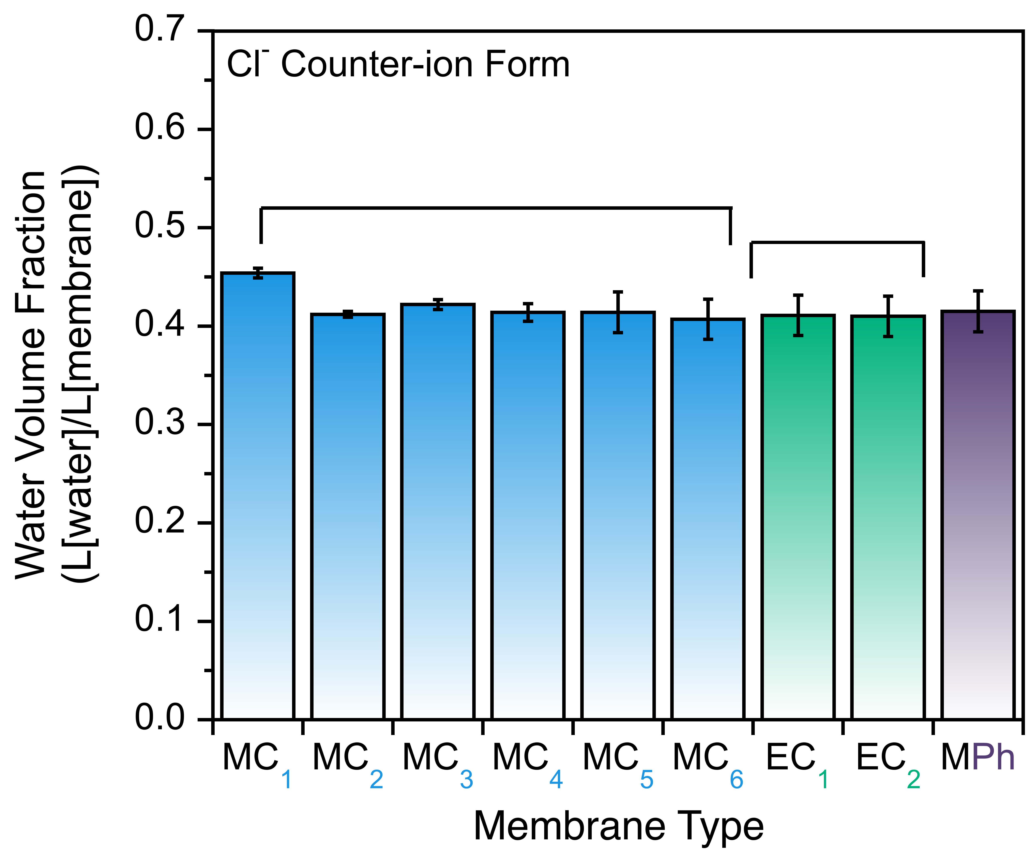
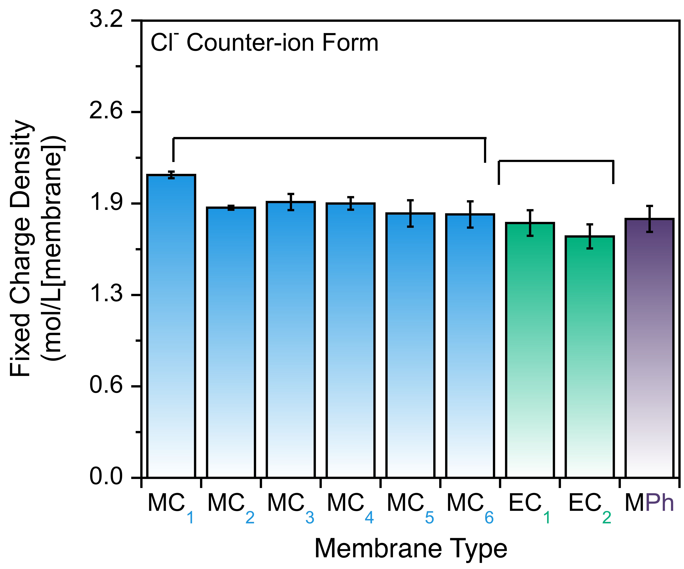

Figure 3. All synthesized AEMs showing similar water and charge content in the chloride counter-ion form
Part 2: Effect of FCG hydrophobicity on sorption and diffusion selectivity in Cl/NO₃ mixtures
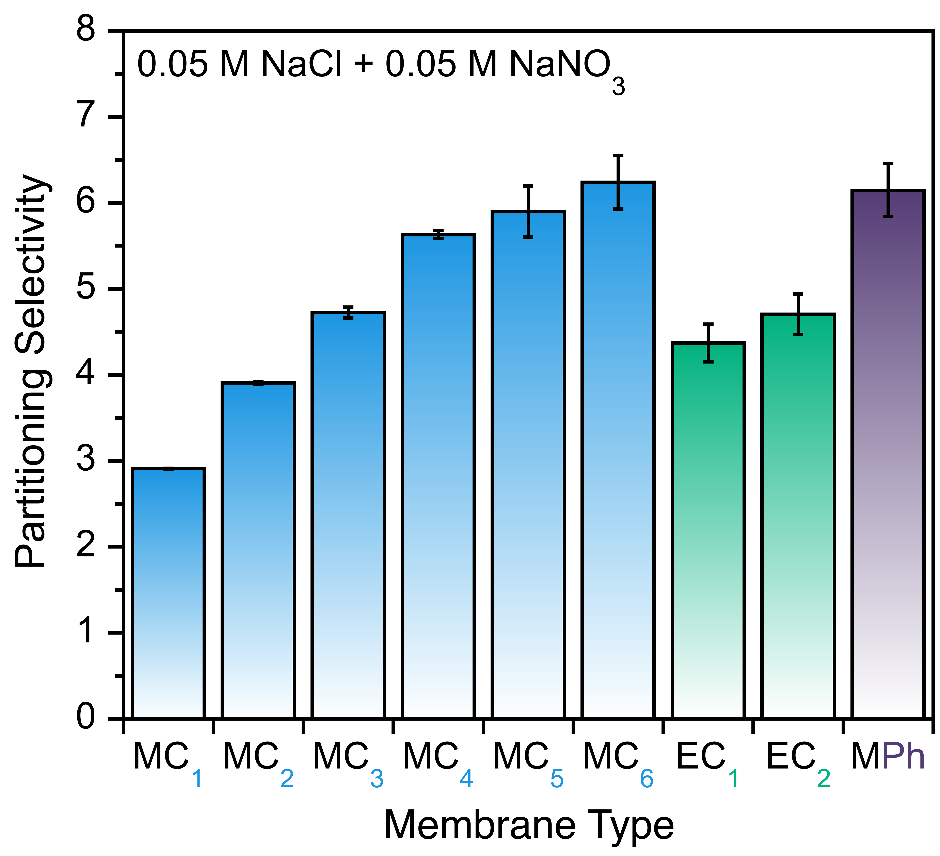
The first goal of this objective is to establish a fundamental understanding of how the membrane-fixed charged group environment (i.e., hydrophobicity) affects the thermodynamic ion partitioning and transport within AEMs. Ion transport in IEMs follows the solution-diffusion mechanism, where ions first partition into the membrane and subsequently diffuse across the membrane under an electrochemical potential gradient. Therefore, I investigated the partitioning and diffusion selectivity separately via idealized and controlled experiments. I used mixed or binary electrolyte solutions containing NaCl and NaNO_{3.} Ion partitioning in the novel AEMs was investigated with NaCl/NaNO₃ salt mixtures with total concentrations of 0.1 M. The concentration of sorbed anions was analyzed via ion chromatography. I hypothesized that increasing the hydrophobicity around the FCG will enhance selectivity for nitrate ions due to mechanisms such as ion dehydration and stronger polymer-ion interactions. Figure 4 shows the NO₃/Cl sorption selectivity for the nine synthesized AEMs with varying FCG structure/hydrophobicity. In general, NO₃ is more selectively preferred by all membranes than Cl for all the alkyl chain length and this selectivity increases with increase in the pendant alkyl chain length. This can attributed to specific ion effects which are consistent with the Hofmeister series, which stems from what is known as the law of matching water affinities (LMWA). LWMA defines that the strength of the interaction between the ion and counter-ion is correlated to the strength of the ion–water interaction. Ions are classified based on their hydration where kosmotropes are strongly hydrated ions interacting with water and polar species while chaotropic are weakly hydrated and have weak interactions with water. The trimethylammonium headgroup exhibits chaotropic behavior (large and low hydration) and according to this sequence, it can form stronger interactions with NO₃⁻ than Cl⁻. With increasing alkyl chain length, we are likely making the environment near the FCG more chaotropic, strengthening interactions with NO₃ further.

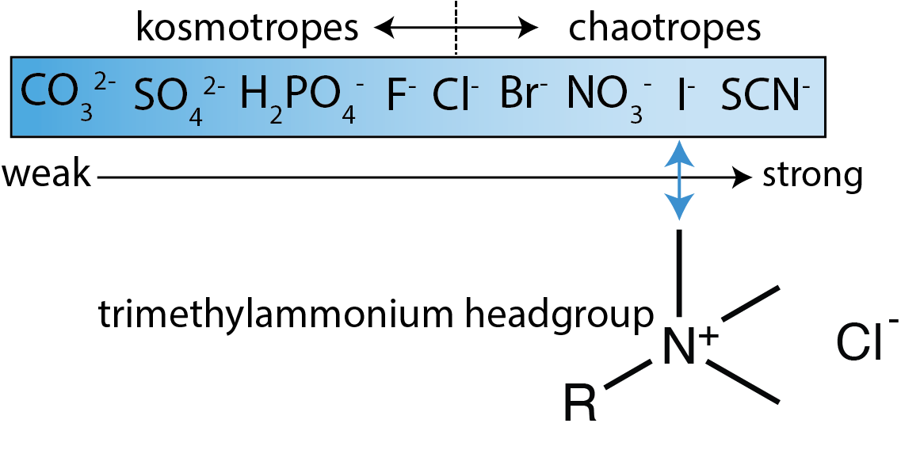
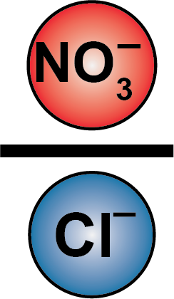

Figure 4. Ion partitioning of NO₃/Cl in mixed salt solution of NaNO₃/NaCl for all nine synthesized AEMs
In addition to the measuring ion partitioning selectivity, we also measured the transport of Cl and NO₃ in the synthesized AEMs via idealized diffusion selectivity measurements. The novel AEMs were characterized via electrochemical impedance spectroscopy (EIS) to measure diffusivity of Cl and NO₃ in the membranes under electric field-driven transport (potential gradient). The experimental setup and diffusion selectivity calculation is shown in Figure 5. Briefly, an ideal diffusion selectivity can be calculated using the diffusion coefficient of the ion in the membrane phase. Then the diffusion selectivity can be defined as the ratio of the diffusion coefficient of the ion in the membrane to that in the solution for both ion $i$ and $j$. The diffusion coefficient of the ion in the membrane can be determined using the Nernst Einstein framework given the ionic conductivity of the ion and the fixed charged density of the membrane are measured. Therefore, the ionic conductivity of the membrane was measured via through-plane conductivity, which refers to the measurement of ionic conductivity perpendicular to the membrane surface, representing how efficiently ions move across the membrane thickness.
Figure 5. Experimental setup for determining idealized diffusion selectivities
The results, shown in Figure 6a, show that nitrate diffusion selectivity decreases strongly with increasing alkyl chain length in MC_{n} series, which means that decreasing diffusion selectivity suggests increasing electrostatic interactions between NO₃– and hydrophobic FCG. This is further shown in a trade – off plot between partitioning and diffusion selectivity. Increasing partitioning selectivity (with increasing alkyl chain length) leads to decreasing diffusion selectivity, highlighting the stronger electrostatic interactions between NO₃⁻ and the increasing FCG hydrophobicity.
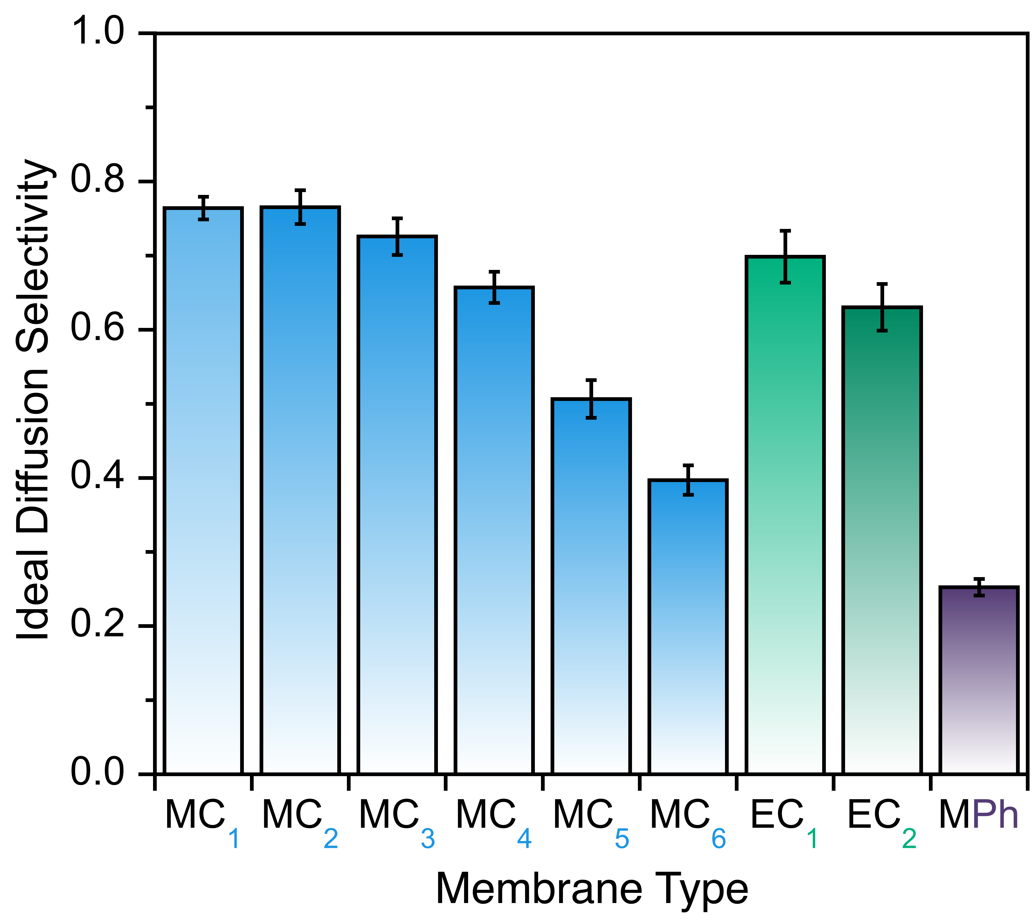

Figure 6. Ideal diffusion selectivity for all nine synthesized AEMs (left) and trade-off plot showing ideal diffusion and partitioning selectivity (right)

Conclusions
This work demonstrates that fixed charged group (FCG) hydrophobicity in anion exchange membranes (AEMs) plays a critical role in governing nitrate selectivity through its influence on both ion sorption and diffusion. By systematically varying the alkyl chain length of pendant groups on quaternary ammonium sites, we successfully modulated the local hydrophobic environment while maintaining consistent membrane charge density and water content. This enabled us to isolate and elucidate the effect of FCG hydrophobicity on ion transport behavior in mixed-salt systems — a major limitation in prior studies. Our results reveal a clear trend: increased FCG hydrophobicity enhances nitrate over chloride sorption, consistent with specific ion effects and the law of matching water affinities (LMWA). At the same time, increased hydrophobicity decreases nitrate diffusion coefficients, suggesting stronger ion–polymer interactions that inhibit mobility. This tradeoff highlights a fundamental challenge in membrane design: optimizing ion selectivity requires a balance between favorable partitioning and sufficient mobility. The insights gained from this study provide valuable design rules for engineering nitrate-selective membranes based on thermodynamic and transport considerations.
The implications of this work are significant. Nitrate contamination is a pressing global issue affecting both human and environmental health, especially in regions with limited access to clean water. By advancing our fundamental understanding of how molecular-scale membrane chemistry affects nitrate selectivity, this project lays the groundwork for scalable, environmentally friendly membrane technologies that can enable energy-efficient nitrate removal and recovery from complex water sources such as brackish groundwater. Ultimately, this research serves the greater good by addressing a critical water quality challenge through the development of practical, sustainable separation technologies. The framework established here can be extended to design membranes for other ion-selective applications, supporting broader goals in water purification, nutrient recovery, and environmental protection.

Next Steps
The final phase of this project will focus on evaluating the performance of the synthesized AEMs in bench-scale electrodialysis (ED) experiments. These tests will provide critical insights into how the nitrate selectivity observed in idealized sorption and diffusion measurements translates to practical separation performance. Specifically, we aim to quantify total transport selectivity in mixed-salt solutions and assess how trends in partitioning and mobility influence overall nitrate removal efficiency under electric field–driven conditions. This phase is essential for validating whether the fundamental structure–property relationships established in Parts 1 and 2 hold true at scale. One anticipated challenge is the fabrication of thin, mechanically robust membrane films suitable for ED operation. Additionally, while our AEMs show promising nitrate selectivity in controlled settings, the magnitude of selectivity may still fall short for practical deployment. To address this, we plan to explore alternative monomer chemistries, including charged groups with more delocalized electronic structures such as imidazolium. These modifications may reduce excessively strong interactions between nitrate and the FCGs, thereby enhancing mobility without sacrificing favorable partitioning—ultimately moving the membranes toward a more optimal position on the selectivity–mobility tradeoff curve. This work may also prompt broader questions regarding the interplay of electrostatics and hydration in ion transport, which we intend to explore through further experimental studies and complementary molecular/theoretical modeling.

References
(1) Williams, A. E.; Lund, L. J.; Johnson, J. A.; Kabala, Z. J. Natural and Anthropogenic Nitrate Contamination of Groundwater in a Rural Community, California. Environ. Sci. Technol. 1998, 32 (1), 32–39. https://doi.org/10.1021/es970393a.
(2) Chinello, D.; Post, J.; De Smet, L. C. P. M. Selective Separation of Nitrate from Chloride Using PVDF-Based Anion-Exchange Membranes. Desalination 2024, 572, 117084. https://doi.org/10.1016/j.desal.2023.117084.
(3) Shrimali, M.; Singh, K. P. New Methods of Nitrate Removal from Water. Environmental Pollution 2001, 112 (3), 351–359. https://doi.org/10.1016/S0269-7491(00)00147-0.
(4) Helfferich, F. Ion Exchange; 1960; Vol. 32. https://doi.org/10.1021/ac60161a609.
(5) [H. Strathmann. Ion-Exchange Membrane Separation Processes; Elsevier: Amsterdam, 2004.
(6) Epsztein, R.; Shaulsky, E.; Qin, M.; Elimelech, M. Activation Behavior for Ion Permeation in Ion-Exchange Membranes: Role of Ion Dehydration in Selective Transport. Journal of Membrane Science 2019, 580 (February), 316–326. https://doi.org/10.1016/j.memsci.2019.02.009.
(7) Ahmadi, H.; Zakertabrizi, M.; Hosseini, E.; Cha-Umpong, W.; Abdollahzadeh, M.; Korayem, A. H.; Chen, V.; Shon, H. K.; Asadnia, M.; Razmjou, A. Heterogeneous Asymmetric Passable Cavities within Graphene Oxide Nanochannels for Highly Efficient Lithium Sieving. Desalination 2022, 538 (May), 115888. https://doi.org/10.1016/j.desal.2022.115888.
(8) Irfan, M.; Ge, L.; Wang, Y.; Yang, Z.; Xu, T. Hydrophobic Side Chains Impart Anion Exchange Membranes with High Monovalent–Divalent Anion Selectivity in Electrodialysis. ACS Sustainable Chem. Eng. 2019, 7 (4), 4429–4442. https://doi.org/10.1021/acssuschemeng.8b06426.
(9) Chen, G. Q.; Wei, K.; Hassanvand, A.; Freeman, B. D.; Kentish, S. E. Single and Binary Ion Sorption Equilibria of Monovalent and Divalent Ions in Commercial Ion Exchange Membranes. Water Research 2020, 175, 115681. https://doi.org/10.1016/j.watres.2020.115681.

